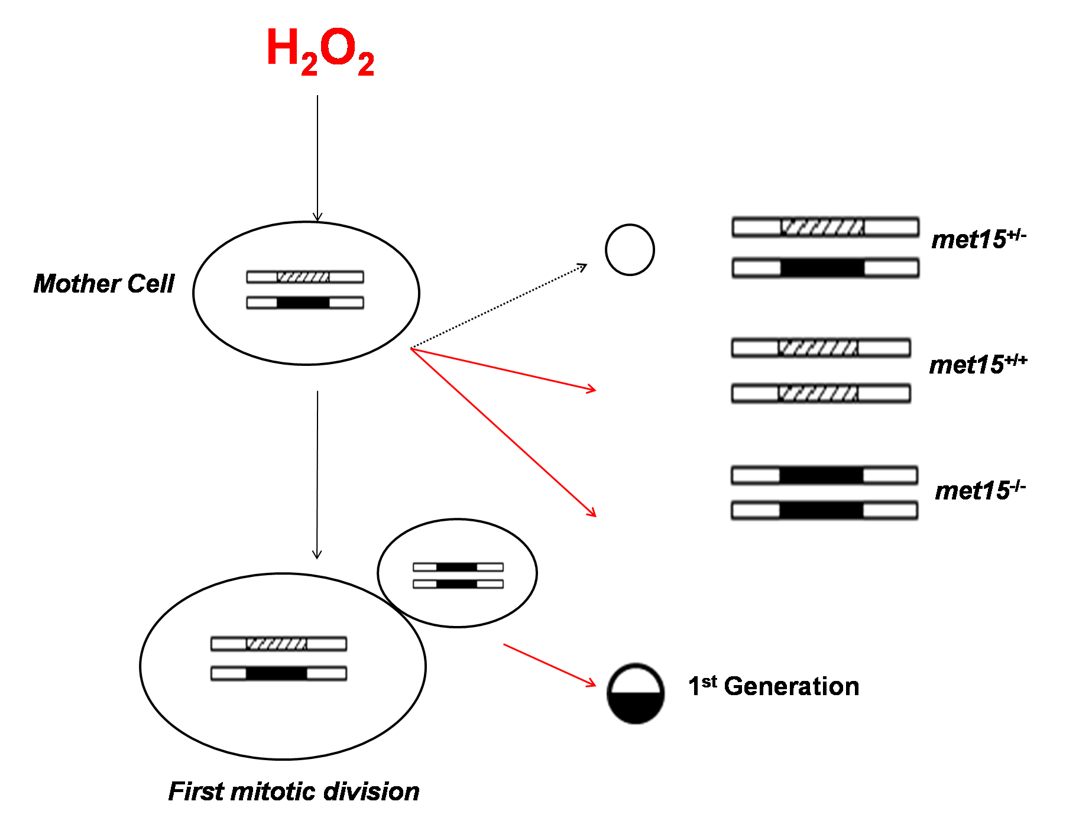

**The detection of H2O2 damages in the yeast genome**. During aging, there is accumulation of oxidative damages in mother cells. These damages are harbored within these mother cells, which increases the likelihood of the damages being transferred to future generations. Ideally, daughter cells should be born free of damages. Through the induction of an oxidative stress response via exposing yeast cells to hydrogen peroxide, we can observe impaired mitotic partition of cellular components.